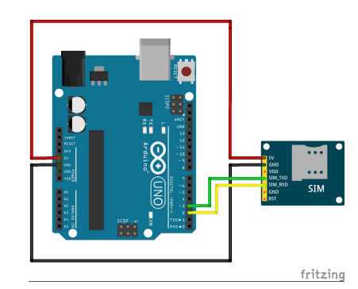The **circuit diagrams** were created using the Fritzing software:

This is for interfacing: SIM800L for GSM communication.

This circuit is for interfacing Soil Moisture, DhT22(Temperature and Humidity) and LDR (with 2.2k ohm resistor) sensor with an OLED display.

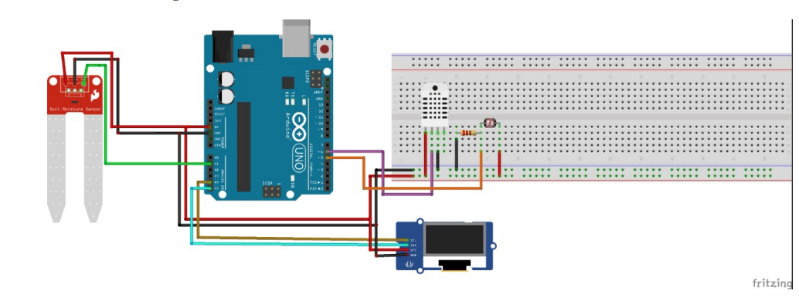

OLED

DHT22

LDR

Buzzer

MQ22

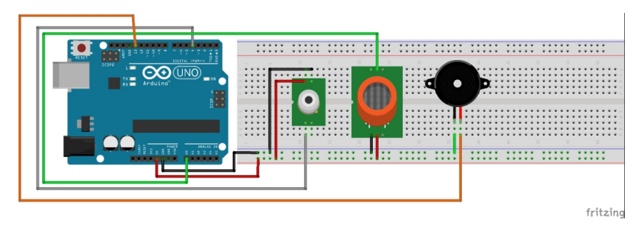

PIR

This is for the Air quality and the PIR sensor, along with a buzzer to work with the PIR sensor.